Relational Model

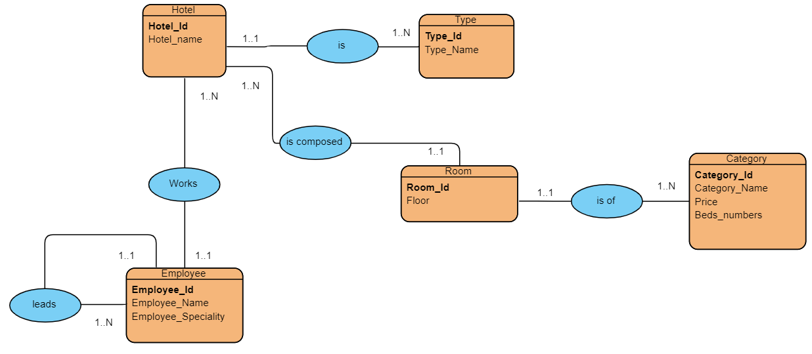

* Relation between **Room** and **Category**

Room(**Room_id**, Floor, **#Category_id**)

Category(**Category_id,** Categoty_Name, Price, Beds_numbers)

* Relation between **Hotel** and **Type**

Hotel(**Hotel_id,** Hotel_name, **#Type_id)**

Type(**Type_id**, Type_Name)

* Relation between **Hotel** and **Room**

Hotel(**Hotel_id,** Hotel_name, **#Room_id)**

Type(**Room_id**, Floor, **#Category_id**)

* Relation between Employees

Employee(**Employee_id**, Employee_Name, Employee_Speciality, **#Chief_id**)

Chief(**#Employee_id**, Grade)

* Relation between **Hotel** and **Employee**

Hotel(**Hotel_id**, Hotel_name, **#Employee_id**)

Employee(**Employee_id**, Employee_Name, Employee_Speciality, **#Chief_id**)